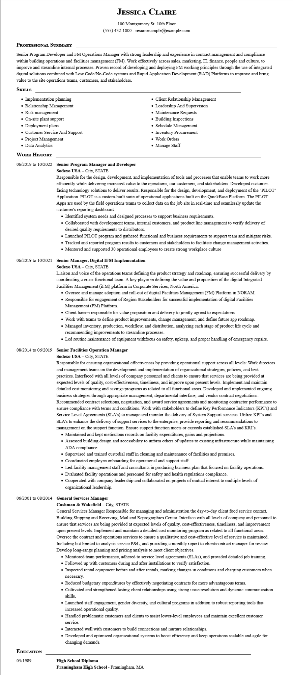
JESSICA CLAIRE
100 Montgomery St. 10th Floor
(555) 432-1000 - resumesample@example.com
PROFESSIONAL SUMMARY
Senior Program Developer and FM Operations Manager with strong leadership and experience in contract management and compliance within building operations and facilities management (FM). Work effectively across sales, marketing, IT, finance, people and culture, to improve and streamline internal processes. Proven record of developing and deploying FM working principles through the use of integrated digital solutions combined with Low Code/No-Code systems and Rapid Application Development (RAD) Platforms to improve and bring value to the site operations teams, customers, and stakeholders.
SKILLS
• Implementation planning
• Relationship Management
• Risk management
• On-site plant support
• Deployment plans
• Customer Service And Support
• Project Management
• Data Analytics
WORK HISTORY
06/2019 to 10/2022 Senior Program Manager and Developer
Sodexo USA - City, STATE
• Client Relationship Management
• Leadership And Supervision
• Maintenance Requests
• Building Inspections
• Schedule Management
• Inventory Procurement
• Work Orders • Manage Staff
Responsible for the design, development, and implementation of tools and processes that enable teams to work more efficiently while delivering increased value to the operations, our customers, and stakeholders. Developed customer- facing technology solutions to deliver results. Responsible for the design, development, and deployment of the "PILOT" Application. PILOT is a custom-built suite of operational applications built on the QuickBase Platform. The PILOT Apps are used by the field operations teams to collect data on the job site in real-time and seamlessly update the customer's reporting dashboard.
• Identified system needs and designed processes to support business requirements.
• Collaborated with development teams, internal customers, and product line management to verify delivery of desired quality requirements to distributors.
• Launched PILOT program and gathered functional and business requirements to support team and mitigate risks.
• Tracked and reported program results to customers and stakeholders to facilitate change management activities. • Mentored and supported 30 operational employees to create strong workplace culture
06/2019 to 10/2021 Senior Manager, Digital IFM Implementation
Sodexo USA - City, STATE
Liaison and voice of the operations teams defining the product strategy and roadmap, ensuring successful delivery by coordinating a cross-functional team. A key player in defining the value and proposition of the digital Integrated Facilities Management (iFM) platform in Corporate Services, North America:
• Oversee and manage adoption and roll-out of digital Facilities Management (FM) Platform in NORAM.
• Responsible for engagement of Region Stakeholders for successful implementation of digital Facilities Management (FM) Platform.
• Client liaison responsible for value proposition and delivery to jointly agreed to expectations.
• Work with teams to define product improvements, change management, and define future app roadmap.
• Managed inventory, production, workflow, and distribution, analyzing each stage of product life cycle and recommending improvements to streamline processes.
• Led routine maintenance of equipment withfocus on safety, upkeep, and proper handling of emergency repairs.
08/2014 to 06/2019 Senior Facilities Operation Manager
Sodexo USA - City, STATE
Responsible for ensuring organizational effectiveness by providing operational support across all levels: Work directors and management teams on the development and implementation of organizational strategies, policies, and best practices. Interfaced with all levels of company personnel and clients to ensure that services are being provided at expected levels of quality, cost-effectiveness, timeliness, and improve upon present levels. Implement and maintain detailed cost monitoring and savings programs as related to all functional areas. Developed and implemented ongoing business strategies through appropriate management, departmental interface, and vendor contract negotiations. Recommended contract selections, negotiation, and award service agreements and monitoring contractor performance to ensure compliance with terms and conditions. Work with stakeholders to define Key Performance Indicators (KPI's) and Service Level Agreements (SLA's) to manage and monitor the delivery of System Support services. Utilize KPI's and SLA's to enhance the delivery of support services to the enterprise, provide reporting and recommendations to management on the support function. Ensure support function meets or exceeds established SLA's and KRI's. • Maintained and kept meticulous records on facility expenditures, gains and projections.
• Assessed building design and accessibility to inform others of updates to existing infrastructure while maintaining ADA compliance.
• Supervised and trained custodial staff in cleaning and maintenance of facilities and premises.
• Coordinated employee onboarding for operational and support staff.
• Led facility management staff and consultants in producing business plan that focused on facility operations.
• Evaluated facility operations and personnel for safety and health regulations compliance.
• Cooperated with company leadership and collaborated on projects of mutual interest to multiple levels of organizational leadership.
06/2001 to 08/2014 General Services Manager
EDUCATION
05/1989
Cushman & Wakefield - City, STATE
General Services Manager Responsible for managing and administration the day-to-day client food service contact, Building Shipping and Receiving, Mail and Reprographics Center. Interface with all levels of company and personnel to ensure that services are being provided at expected levels of quality, cost-effectiveness, timeliness, and improvement upon present levels. Implement and maintain a detailed cost monitoring program as related to all functional areas. Oversee the contract and operations services to ensure a qualitative and cost-effective level of service is maintained. Including but limited to analysis service P&L, and providing a monthly report to client/contract manager for review. Develop long-range planning and pricing analysis to meet client objectives.
• Monitored team performance, adhered to service level agreements (SLAs), and provided detailed job training.
• Followed up with customers during and after installations to verify satisfaction.
• Inspected rental equipment before and after rentals, marking changes in conditions and charging customers when necessary.
• Reduced budgetary expenditures by effectively negotiating contracts for more advantageous terms.
• Cultivated and strengthened lasting client relationships using strong issue resolution and dynamic communication skills.
• Launched staff engagement, gender diversity, and cultural programs in addition to robust reporting tools that increased operational quality.
• Handled problematic customers and clients to assist lower-level employees and maintain excellent customer
service.
• Interacted well with customers to build connections and nurture relationships.
• Developed and optimized organizational systems to boost efficiency and keep operations scalable and agile for changing demands.
High School Diploma
Framingham High School - Framingham, MA

